Faculty of Engineering and Built Environment Cape Peninsula University of Technology
Department of Electrical, Electronic and Computer Engineering (DEECE)
Bachelor of Engineering Technology: Electrical Engineering

CONTROL SYSTEMS 3 (CSS370S)
FINAL PROJECT PART 1: GA1 EVALUATION
SYSTEM DESIGN & DEVELOPMENT, CLOSED LOOP CONTROL SYSTEM DESIGN, SIMULATION & PRACTICAL IMPLEMENTATION
PROJECT V01 - ONE COUNTER CRUISE SYSTEM
Circuit focus: counter/display stage, 74LS85 comparator, gate logic and NE555 flashing warning

Student Name: Surname and Initials
Student Number: Number

Lecturer: Dr N. Dube
Date: 19 June 2026

NOTE: PLEASE SAVE THE FILE AS,
Surname_Initials_StudentNumber_GA1_PROJECT_2026

Declaration

I, ……………………………………………………, declare that the contents of this document represent my own unaided work, and that the work submitted here has not been copied from other sources without proper referencing. All information obtained from other sources have been acknowledged. Furthermore, it represents my own opinions and not necessarily those of the Cape Peninsula University of Technology.

Full Names and Surname: ............................................................
Student Number: ............................................................

Signature: ............................................................ Date: ........ / ........ / 2026

Summary/Abstract

This report presents the design and simulation of Project V01, a one-counter cruise-speed control demonstration for Control Systems 3. The project required a practical electronic solution without microcontroller or PLC control. The solution therefore uses counter/display circuitry, BCD logic, a 74LS85 magnitude comparator, range-detection gates and an NE555 astable timer to show the current speed, compare it with a selected cruise reference and produce the required indicator outputs.
The system displays the vehicle speed from 00 up to the required maximum of 10. Speeds 00 to 05 are indicated by the green output, speeds 06 to 09 are indicated by the amber/yellow output, and the red indicator flashes when the selected cruise speed is reached or exceeded. The design was developed stage by stage so that the counter, display, comparator, range logic and flashing-warning sections could be verified individually before being combined into the complete simulated control system.

Table of Contents
Declaration........................................................................................................................i
Summary/Abstract.............................................................................................................i
Table of Figures (TOF).................................................................................................iii
Table of Tables (TOT)....................................................................................................iv
Table of Equations.........................................................................................................v
Table of Acronyms........................................................................................................vi
1. Introduction.............................................................................................................1
2. System description...................................................................................................2
2.1. Stage 1: Development and overall approach to solution of automated system.................4
2.2. Stage 2: Development and solution of the analog detection/sensors stage.......................5
2.3. Stage 3: Development and solution of determination of increasing/decreasing speed........6
2.4. Stage 4: Development and solution of relevant alarms/indicators/displays of the system...7
2.5. Stage 5: Overall approach to system design and solution development..........................8
3. Observations and results..........................................................................................9
4. Conclusion............................................................................................................10
Bibliography..............................................................................................................11
Glossary of Terms.....................................................................................................12
Appendices...............................................................................................................13
APPENDIX A: Practical evaluation scheme......................................................................13
APPENDIX B: Report evaluation scheme........................................................................14

Table of Figures (TOF)
Table 1: Table of figures
Figure | Title | Main section
Figure 1 | Project V01 automated cruise-speed control system overview | System description
Figure 2 | Functional block diagram of the one-counter cruise system | Stage 1
Figure 3 | Simulated electronic schematic used for the project implementation | Stage 5
Figure 4 | Flow chart for the cruise-speed decision sequence | Observations and results

Table of Tables (TOT)
Table 2: Table of tables
Table | Title | Main section
Table 1 | Table of figures | Front matter
Table 2 | Table of tables | Front matter
Table 3 | Table of equations | Front matter
Table 4 | Table of acronyms | Front matter
Table 5 | Main component function table | System description
Table 6 | Input and counter control table | Stage 3
Table 7 | Display and indicator truth table for 00 to 10 | Stage 4
Table 8 | Comparator and red warning truth table | Observations and results
Table 9 | Final operating summary | Observations and results

Table of Equations
Table 3: Table of equations
Equation | Description | Main section
Equation 1 | Base green range logic for speeds 00 to 05 | Stage 4
Equation 2 | Base yellow range logic for speeds 06 to 09 | Stage 4
Equation 3 | Final green logic with maximum-speed correction | Stage 4
Equation 4 | 74LS85 comparator warning condition | Observations and results
Equation 5 | Red flashing warning enable condition | Observations and results

Table of Acronyms
Table 4: Table of acronyms
Acronym | Meaning
BCD | Binary Coded Decimal
CLK | Clock input
DIP | Dual in-line package switch
LED | Light Emitting Diode
LSB | Least Significant Bit
NE555 | 555 timer integrated circuit used as an astable flasher
PLC | Programmable Logic Controller
VCC | Positive supply voltage

Introduction
The project was performed to demonstrate stage-wise design, implementation and evaluation of an electronic control-system solution. The required application is a simulated vehicle cruise-speed control system that displays the current speed, compares it with a set-speed reference and activates the correct visual warning state.
The aim of the project was to design a practical electronic circuit that demonstrates the cruise-speed control function without using a microcontroller or PLC. The design had to provide a current-speed display, a selected cruise-speed input, a green indication for speeds 0 to 5, an amber/yellow indication for speeds 6 to 9, a flashing red indication when the cruise value is reached and a visible maximum speed of 10.
The problem addressed by the project is the conversion of a changing speed value into meaningful digital outputs using only electronic components. The system must count the speed, display the speed, compare the current speed to a set point and prevent confusion when the maximum value is reached. This is a broadly defined engineering problem because it requires digital counting, comparison, logic decision-making, display decoding and warning generation to work together.
The project is relevant to Control Systems 3 because it shows how a practical control objective can be divided into functional stages. Each stage can be tested independently before being connected to the next stage. This reduces fault-finding difficulty and improves the reliability of the final circuit.
The objectives were achieved in simulation. The circuit produces the required green, yellow and flashing red outputs, displays the maximum speed of 10 and uses a logic-based reset/maximum-speed control path rather than relying only on a manual reset button. The main lesson from the work is that the final solution becomes easier to explain and improve when the design is built from smaller verified blocks.

System description
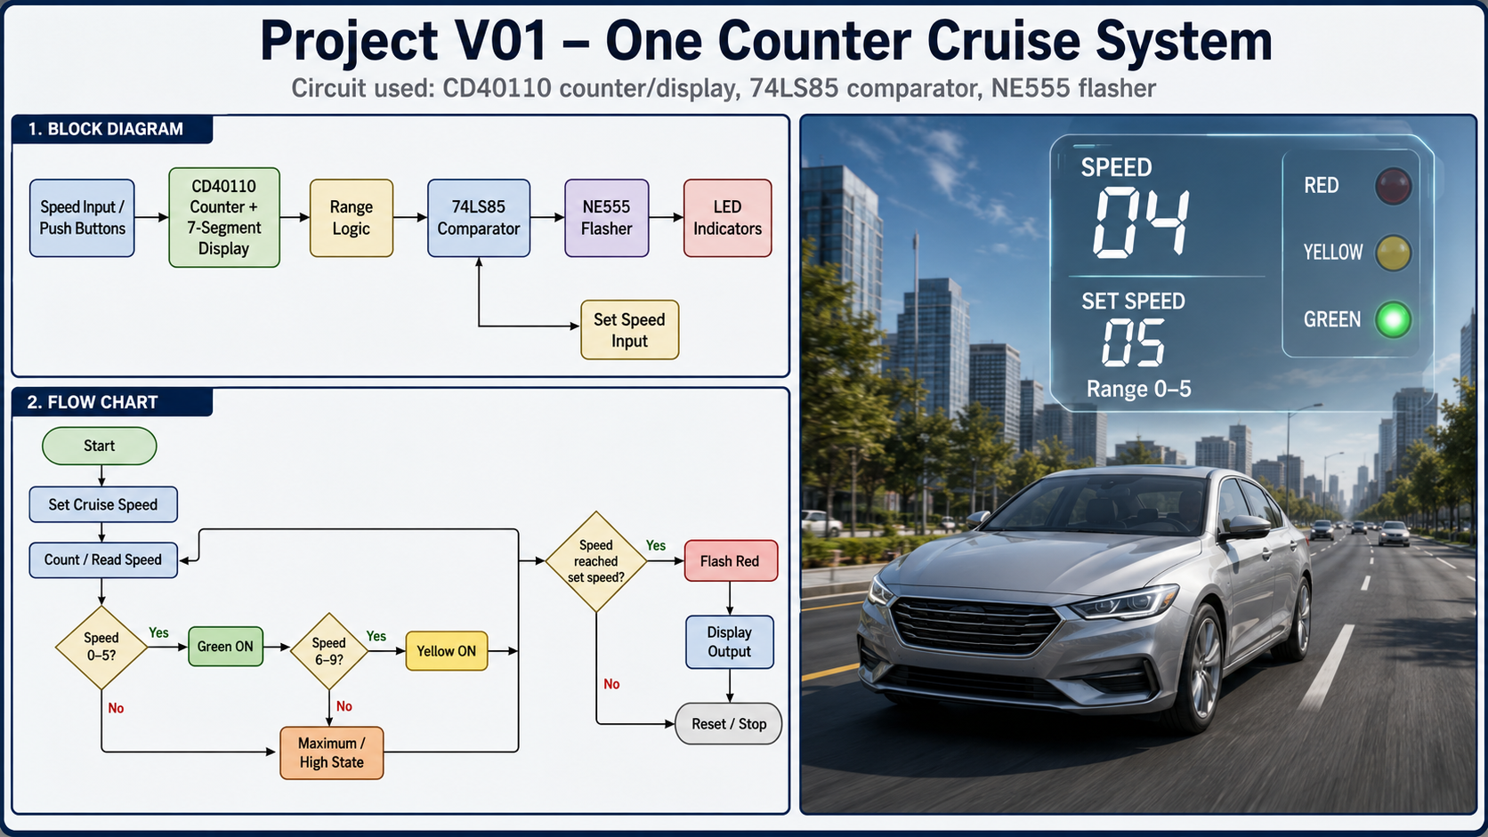
Figure 1: Project V01 automated cruise-speed control system overview.

Figure 1 introduces the complete Project V01 concept. The left side summarises the block diagram and the flow chart, while the right side shows how the simulated vehicle state is represented visually. The design is treated as an electronic implementation of a cruise-speed control display and warning system. The counter/display stage produces the current speed, the set-speed input provides the reference, the comparator checks whether the reference has been reached, and the indicator stage produces green, yellow or flashing red outputs.
Table 5 identifies the main hardware blocks used in the final solution. The counter and display section is responsible for representing the current speed, while the comparator and NE555 sections are responsible for the cruise warning state.
Table 5: Main component function table
Component / block | Circuit part | Purpose in the project
Speed input / push buttons | Manual electronic input stage | Represents increase, decrease and reset actions during simulation testing.
Counter/display function | CD40110 concept or CD4029 with CD4511 display drivers in the supplied schematic | Counts and displays the current speed as a seven-segment decimal value.
Range logic | AND, OR, NOT and XOR gates | Separates speeds 00-05, 06-09 and maximum-speed logic.
74LS85 comparator | 4-bit magnitude comparator | Compares current speed with the selected cruise set-speed reference.
DIP switch set-speed input | Manual BCD reference input | Provides the cruise-speed value used by the comparator.
NE555 flasher | Astable timer circuit | Produces the flashing red warning signal.
LED indicators | Green, yellow and red outputs | Shows the operating condition of the simulated cruise system.

Stage 1: Development and overall approach to solution of automated system
The complete cruise-speed system was first divided into functional blocks so that each block could be tested independently. The system starts with a speed input stage, then passes the current speed value to the counter/display stage, the range-logic stage and the comparator stage. The comparator output then enables the flashing red warning stage when the set-speed condition is reached.
Figure 2 shows the block-level design used to guide the practical implementation. This stage was important because it confirmed the signal flow before the detailed circuit was assembled.
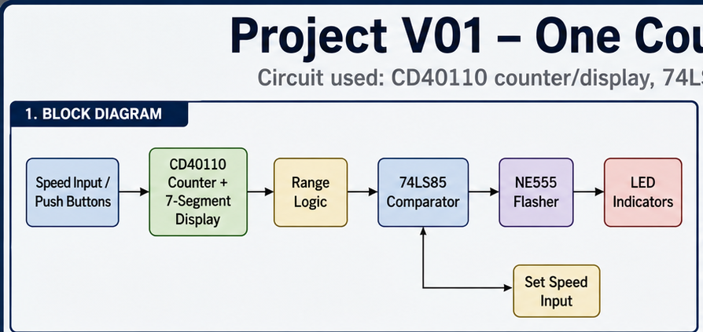
Figure 2: Functional block diagram of the one-counter cruise system.

Stage 2: Development and solution of the analog detection/sensors stage
In the supplied simulation, the analogue detector stage is represented by manual electronic speed inputs. The push buttons provide controlled test pulses for increasing, decreasing and resetting the displayed speed. This approach makes the logic easier to verify because every count can be checked directly on the seven-segment display.
For a physical extension of the project, the detector stage can be replaced by an analogue speed sensor and signal-conditioning circuit. The conditioned signal would need to be scaled to the detector range suggested in the brief and then converted into a count or comparison signal. In this report, the focus remains on the validated counter, comparator and indicator logic.

Stage 3: Development and solution of determination of increasing/decreasing speed (digital and analog solutions)
The increasing/decreasing speed stage is controlled by the UP and DOWN inputs. A pulse on the UP input increases the displayed speed by one count, while a pulse on the DOWN input decreases it by one count. The manual RESET input is included for initialisation and testing, but the cruise reset/maximum-speed action is treated separately as a logic-based function.
Table 6 summarises the input actions used to verify the counter behaviour in simulation. The invalid case occurs when UP and DOWN are activated together and should be avoided during normal operation.
Table 6: Input and counter control table
DOWN | UP | RESET | Clock | Direction | Counter action | Display result
0 | 0 | 0 | 0 | Previous | Hold | Same speed remains displayed
0 | 1 pulse | 0 | 1 pulse | UP | Count up | Speed increases by 1
1 pulse | 0 | 0 | 1 pulse | DOWN | Count down | Speed decreases by 1
1 | 1 | 0 | 1 | Invalid | Not recommended | May behave incorrectly
X | X | 1 | X | Reset | Manual clear | Display returns to 00

Stage 4: Development and solution of relevant alarms/indicators/displays of the system
The alarm, indicator and display stage converts the counter output into visible information. The seven-segment display shows the current speed. The green indicator represents the 00 to 05 speed range, the yellow indicator represents the 06 to 09 range, and the red indicator flashes when the selected cruise speed is reached or exceeded. At speed 10, green and yellow are both OFF while the red warning remains active.
The range decision is implemented using BCD logic equations. In the equations, / means NOT, a dot means AND, and + means OR. A2 is the tens signal used to identify the maximum-speed condition.
(1) Base Green = /D . (/C + /B)
Equation 1: Base green range logic for speeds 00 to 05.
(2) Base Yellow = (/D . C . B) + (D . /C . /B)
Equation 2: Base yellow range logic for speeds 06 to 09.
(3) Final Green = Base Green XOR A2
Equation 3: Final green logic with maximum-speed correction.
Table 7: Display and indicator truth table for 00 to 10
Speed | Tens | Units | A2 | Unit BCD | Green | Yellow | Red warning condition
00 | 0 | 0 | 0 | 0000 | ON | OFF | Only if set speed <= current speed
01 | 0 | 1 | 0 | 0001 | ON | OFF | Only if set speed <= current speed
02 | 0 | 2 | 0 | 0010 | ON | OFF | Only if set speed <= current speed
03 | 0 | 3 | 0 | 0011 | ON | OFF | Only if set speed <= current speed
04 | 0 | 4 | 0 | 0100 | ON | OFF | Only if set speed <= current speed
05 | 0 | 5 | 0 | 0101 | ON | OFF | Only if set speed <= current speed
06 | 0 | 6 | 0 | 0110 | OFF | ON | Flashes if cruise set speed reached
07 | 0 | 7 | 0 | 0111 | OFF | ON | Flashes if cruise set speed reached
08 | 0 | 8 | 0 | 1000 | OFF | ON | Flashes if cruise set speed reached
09 | 0 | 9 | 0 | 1001 | OFF | ON | Flashes if cruise set speed reached
10 | 1 | 0 | 1 | 0000 | OFF | OFF | Flashing at maximum speed

Stage 5: Overall approach to system design and solution development
After the individual stages were checked, the complete circuit was assembled in simulation. Figure 3 shows the final schematic used to verify the complete cruise-speed control solution. The schematic includes the counter/display section, the range logic, the 74LS85 comparator, the DIP-switch set-speed reference, the transistor/relay enable path and the NE555 red flasher.
The design approach followed a practical engineering sequence: define the required outputs, produce the counter and display first, add the range logic, add the comparator and finally connect the flashing warning stage. This reduced the risk of connecting a full circuit before the individual sections were understood.
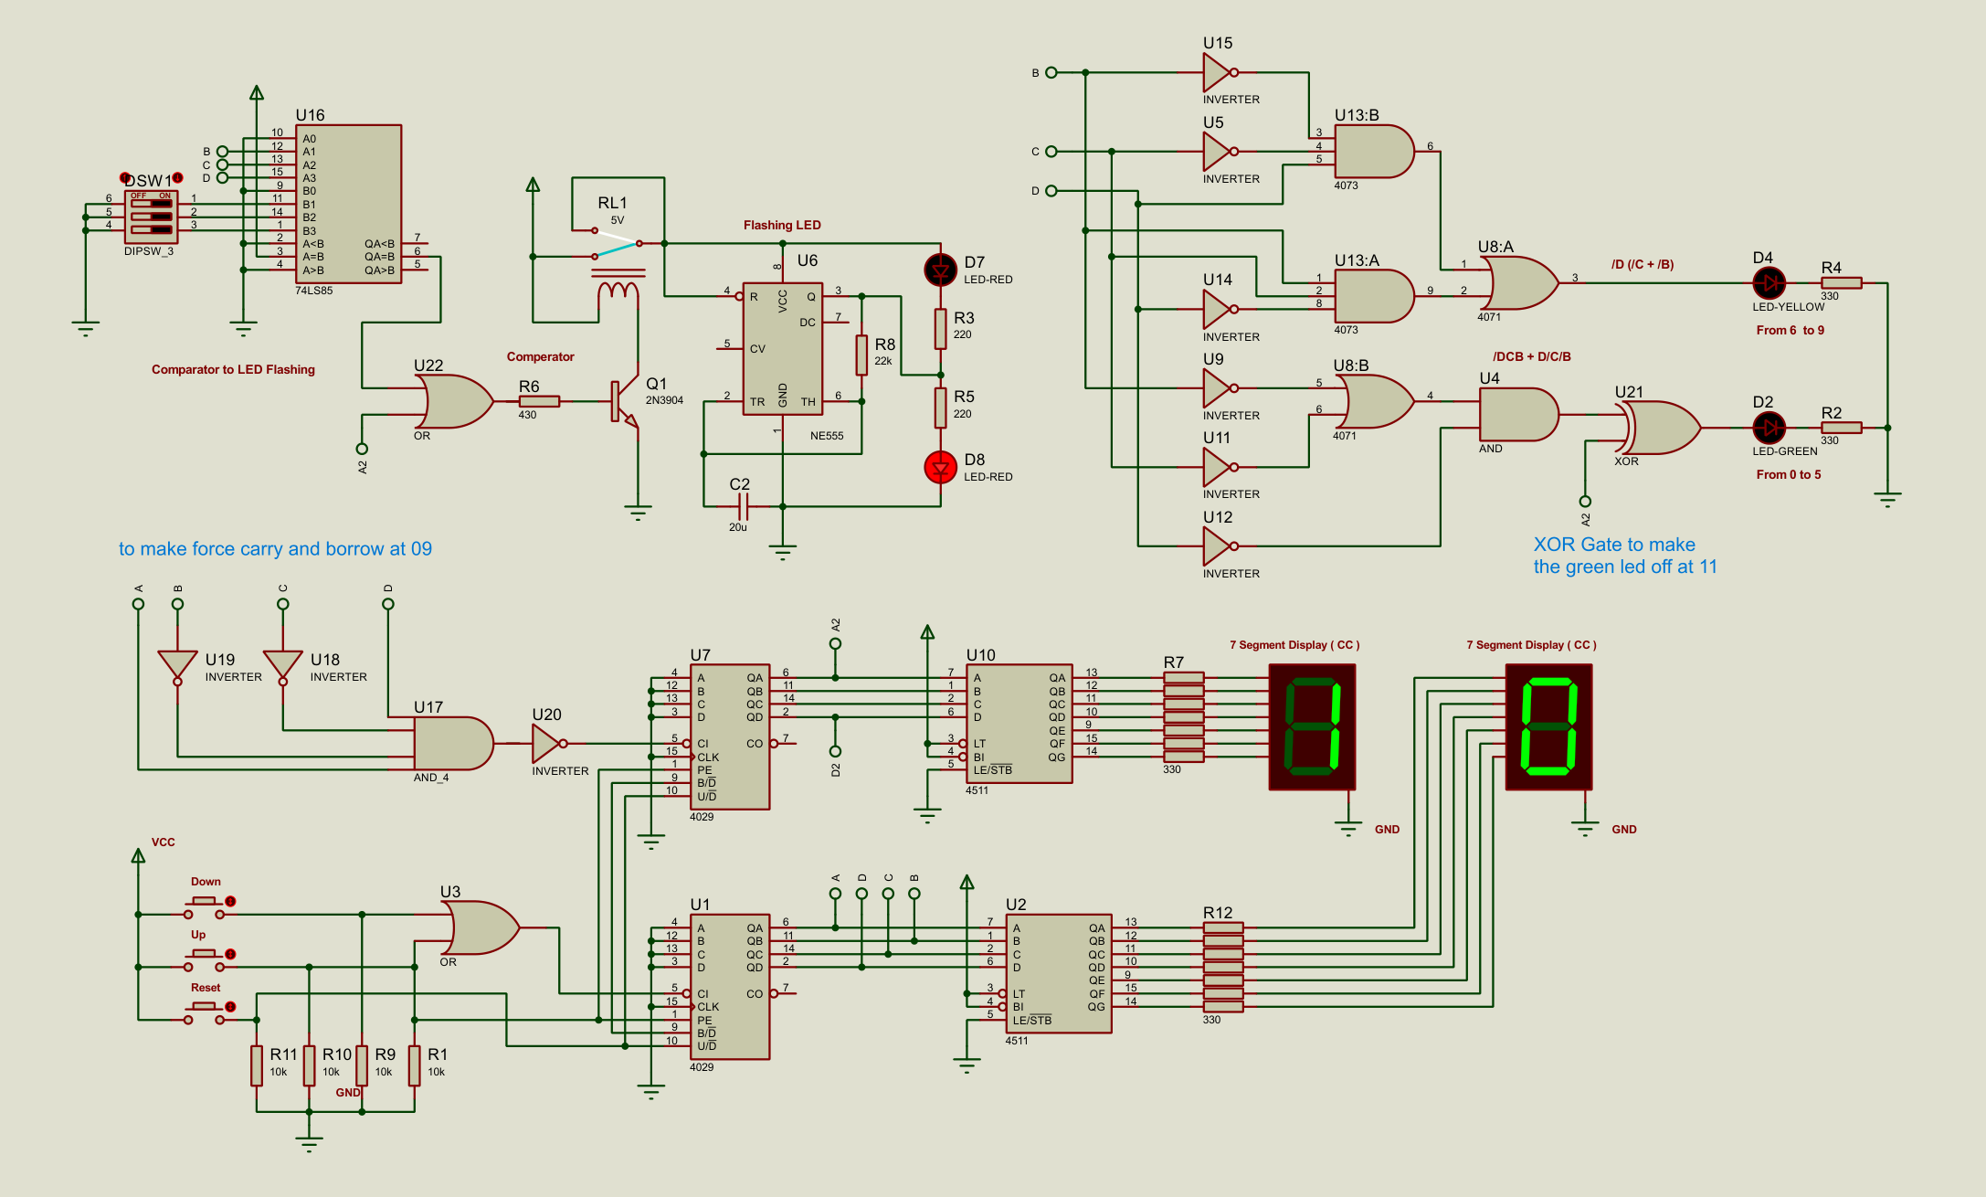
Figure 3: Simulated electronic schematic used for the project implementation.

Observations and results
The observed simulation behaviour matches the required control states. Figure 4 presents the logic flow used during testing. The circuit reads or counts the current speed, checks the range, compares the current speed with the selected cruise value and activates the required indicator output.
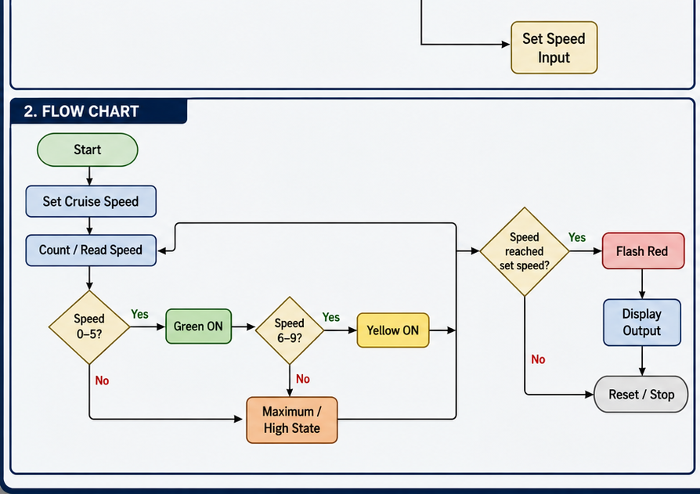
Figure 4: Flow chart for the cruise-speed decision sequence.
Table 8 verifies the comparator section. The 74LS85 output used for the warning is active when the current speed is equal to or greater than the selected set speed.
(4) F = (A > B) + (A = B)
Equation 4: Comparator warning condition.
(5) Warning Enable = F + A2
Equation 5: Red flashing warning enable condition.
Table 8: Comparator and red warning truth table
Current speed condition | A>B | A=B | A<B | F | A2 | Warning enable | Red LED
Current speed < Set speed | 0 | 0 | 1 | 0 | 0 | 0 | OFF
Current speed = Set speed | 0 | 1 | 0 | 1 | 0 | 1 | Flashing
Current speed > Set speed | 1 | 0 | 0 | 1 | 0 | 1 | Flashing
Maximum speed 10 reached | X | X | X | X | 1 | 1 | Flashing
Table 9: Final operating summary
Condition | Green | Yellow | Flashing red | Display action
Speed 00 to 05 | ON | OFF | Depends on comparator set speed | Displays 00 to 05
Speed 06 to 09 | OFF | ON | Depends on comparator set speed | Displays 06 to 09
Current speed < set speed | Range LED works | Range LED works | OFF | Displays current speed
Current speed = set speed | Range LED works | Range LED works | Flashing | Displays current speed
Current speed > set speed | Range LED works | Range LED works | Flashing | Displays current speed
Speed 10 | OFF | OFF | Flashing | Displays maximum speed 10
Count above 10 | OFF | OFF | Reset path active | Returns to 00

Conclusion
Project V01 was successfully developed as an electronic one-counter cruise-speed control demonstration. The project problem was solved by dividing the system into speed input, counter/display, range logic, comparator and flashing-warning stages. This made it possible to test the design stage by stage before combining the complete circuit.
The final simulated design meets the main requirements of the brief. It avoids microcontroller and PLC control, displays the current speed, shows green for speeds 00 to 05, shows yellow for speeds 06 to 09, flashes red when the cruise set speed is reached or exceeded, and displays the maximum speed of 10. The main limitation is that the speed detector is represented by manual pulses instead of a real analogue sensor. A future improvement would be to add a physical sensor and conditioning circuit before the counter/display stage.

Bibliography
[1] Cape Peninsula University of Technology, Department of Electrical, Electronic and Computer Engineering, Control Systems 3 (CSS370S) GA1 Project 2026 brief, 2026.
[2] Project V01 - One Counter Cruise System visual overview, block diagram and flow chart supplied for the report, 2026.
[3] New Project electronic schematic supplied for the cruise-speed control circuit, 2026.
[4] New Project Cruise Speed Control Truth Tables, CD4029 counters, CD4511 common-cathode displays, 74LS85 comparator and NE555 flashing warning, 2026.
[5] Cape Peninsula University of Technology, BET Project Report Guidelines, 2026.

Glossary of Terms
Table 10: Glossary of terms
Term | Explanation
Cruise speed | The selected reference speed used by the comparator.
Current speed | The speed value shown on the seven-segment display.
Comparator | A circuit that checks whether one binary value is less than, equal to or greater than another.
Astable timer | A timer circuit that continuously changes output state to create a flashing signal.
Maximum speed | The highest visible speed required by the project, equal to 10.

Appendices

APPENDIX A: Practical evaluation scheme
A. PRACTICAL EVALUATION: | MARK WEIGHT | OBTAINED MARK
INTRODUCTION & APPROACH TO SOLUTION | 10%
1. Identify/Define Problem:  Ability to identify and/or articulate a problem. | 10%
EACH PROJECT STAGE DEMO | 20%
2. Contextualize Problem:  Ability to understand the problem within a larger context (problem within a problem). | 20%
PROJECT SOLUTION/(WHY IS IT NOT WORKING) | 20%
3. Formulate Strategies for Solving a Problem:  Ability to identify strategies for solving problems (brainstorming, research, trial and error). | 20%
PRACTICAL PROJECT DESIGN & RESULTS (BASIC QUESTIONS) | 10%
4. Recognize and Consider Assumptions:  Ability to recognize and consider assumptions when solving a problem. | 10%

APPENDIX B: Report evaluation scheme
B. REPORT EVALUATION: | MARK WEIGHT | OBTAINED MARK
REPORT ON THE RESEARCH DONE, DEVELOPMENT AND APPROACH TO AND IMPLEMENTATION OF SOLUTION (STAGEWISE SOLUTION DEVELOPMENT) | 25%
5. Implement Solutions:  Ability to implement a practical solution to address the problem. | 25%
REPORT CONCLUSION & OVERALL PROJECT PRESENTATION | 15%
6. Evaluate Solution Implementation:  Ability to evaluate solution implementation and impact (performance, limitations, cost (time and money), consequences of failure, risk). | 15%

