Faculty of Engineering and Built Environment Cape Peninsula University of Technology
Department of Electrical, Electronic and Computer Engineering (DEECE)
Bachelor of Engineering Technology: Electrical Engineering

CONTROL SYSTEMS 3 (CSS370S)
FINAL PROJECT PART 1: GA1 EVALUATION
SYSTEM DESIGN & DEVELOPMENT, CLOSED LOOP CONTROL SYSTEM DESIGN, SIMULATION & PRACTICAL IMPLEMENTATION

Student Name: Surname and Initials
Student Number: Number

Lecturer:
Date: 19 June 2026

NOTE: PLEASE SAVE THE FILE AS,
Surname_Initials_StudentNumber_GA1_PROJECT_2026

Declaration

I, ……………………………………………………, declare that the contents of this document represent my own unaided work, and that the work submitted here has not been copied from other sources without proper referencing. All information obtained from other sources have been acknowledged. Furthermore, it represents my own opinions and not necessarily those of the Cape Peninsula University of Technology.

Full Names and Surname: ????
Student Number: ????

Signature: …………….…………………………………. Date: …??…Month…Year………

Summary/Abstract (select one)

- Give a short description of what is expected, use information from Section A of the Brief document.
- Give concluding remarks on how the problem is solved or was intended to be solved.

Table of Contents
Declaration i
Summary/Abstract (select one) i
Table of Figures (TOF) iii
Table of Tables (TOT) iv
Table of Equations (if these exists/delete this heading if not) v
Table of Acronyms vi
1. Introduction 1
2. System description 2
2.1. Stage 1: Development and overall approach to solution of automated system 4
2.2. Stage 2: Development and solution of the analog detection/sensors stage 5
2.3. Stage 3: Development and solution of determination of increasing/decreasing speed (digital and analog solutions) 6
2.4. Stage 4: Development and solution of relevant alarms/indicators/displays of the system 7
2.5. Stage 5: Overall approach to system design and solution development 8
3. Observations and results 9
4. Conclusion 9
Bibliography 10
Glossary of Terms (if required, alternatively remove this heading) 11
Appendices 12
APPENDIX A: Practical evaluation scheme 12
APPENDIX B: Report evaluation scheme 13

Table of Figures (TOF)

Table of Tables (TOT)

Table of Equations (if these exists/delete this heading if not)

Table of Acronyms

Introduction
Opening statement:
- Why is the project performed?
Aim of the project
What was the aim of this project?
Problem statement
- Specify the concise summary of the research problem that is being addressed.
- Contextualize the problem. What exactly is already known?
- Describe the exact issue your research/project will address.
- What do we still need to know?
- Show the relevance of the problem.
Final introduction statements:
- Were the objectives/goals achieved?
- Use information from SECTION A – PROJECT DESCRIPTION to assist.
- Any lessons from the project.
(All the red text must be deleted after producing the report text.)

System description
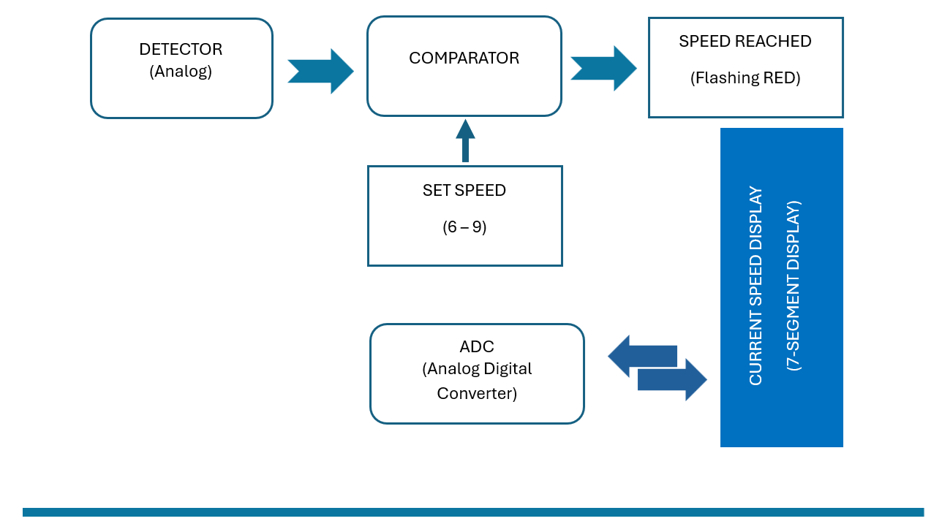
Figure 1: Automated parking simulated control system.

Give a short description of how each part of the project was solved. Also specify how these will be demonstrated/presented. And what was of noticeable observation for each case.
NOTE: Keep in mind these are not the final descriptions, keep it short. The full details are covered in the sections below.

Stage 1: Development and overall approach to solution of automated system

Stage 2: Development and solution of the analog detection/sensors stage

Stage 3: Development and solution of determination of increasing/decreasing speed (digital and analog solutions)

Stage 4: Development and solution of relevant alarms/indicators/displays of the system

Stage 5: Overall approach to system design and solution development

Observations and results

Conclusion

Bibliography

Glossary of Terms (if required, alternatively remove this heading)

Appendices

APPENDIX A: Practical evaluation scheme
A. PRACTICAL EVALUATION: | MARK WEIGHT | OBTAINED MARK
INTRODUCTION & APPROACH TO SOLUTION | 10%
1. Identify/Define Problem:  Ability to identify and/or articulate a problem. | 10%
EACH PROJECT STAGE DEMO | 20%
2. Contextualize Problem:  Ability to understand the problem within a larger context (problem within a problem). | 20%
PROJECT SOLUTION/(WHY IS IT NOT WORKING) | 20%
3. Formulate Strategies for Solving a Problem:  Ability to identify strategies for solving problems (brainstorming, research, trial and error). | 20%
PRACTICAL PROJECT DESIGN & RESULTS (BASIC QUESTIONS) | 10%
4. Recognize and Consider Assumptions:  Ability to recognize and consider assumptions when solving a problem. | 10%

APPENDIX B: Report evaluation scheme
B. REPORT EVALUATION: | MARK WEIGHT | OBTAINED MARK
REPORT ON THE RESEARCH DONE, DEVELOPMENT AND APPROACH TO AND IMPLEMENTATION OF SOLUTION (STAGEWISE SOLUTION DEVELOPMENT) | 25%
5. Implement Solutions:  Ability to implement a practical solution to address the problem. | 25%
REPORT CONCLUSION & OVERALL PROJECT PRESENTATION | 15%
6. Evaluate Solution Implementation:  Ability to evaluate solution implementation and impact (performance, limitations, cost (time and money), consequences of failure, risk). | 15%

